Notability

**Introduction section:**

In this assignment, I am going to talk about Notability, an application that lets you record information in a wide variety of formats. I am going to explain and break down into different sections:

* Abstraction
* States
* Data representation
* Data compression
* Modularity
* Networks

I am going to explain with my example application work using those concepts and describe how different technical choices for the implementation of the application might affect its behaviour, or how different situations might affect the behaviour of the application.

**Abstraction:**

An abstraction is a simplifying key feature to understand what is going on in a system to provide you with an overall observation of the program. Abstraction of Notability that it is an application that allows you to record formats like photo, drawing, text, handwriting and voice recording to create notes. It allows users to do note-taking and share through different platforms such as MAC, Windows, Linux and ARM-based iOS and Android.

**States:**

States in computer science it’s a temporary configuration, a condition or position of a system and can affect and response to interactions. A state machine has 4 elements: state, event, action and transition. An event is condition that trigger a trigger condition or password. An action is what to do after an event/condition is met. A transition is a description that describe the changing states from one to another. State can change automatically when the condition is met or by user interactions.

States in Notability recording and playback

There are many states when the user record and playback an audio recording.

Example: Recording Audio

1. Tap  to start recording. An input meter and timer will appear and it enters a “start recording state”.
2. Tap again to stop recording and stores the recoding then it will enter an end “terminate recording state”.

Example: Playing Audio

1. Tap to enter playback mode “pending state”.
2. Tap  to play a note’s audio and enter the “playing state”.
3. Tap  to pause the audio and enter the “pause state”.

**Data Representation:**

Data Representation is the form in which data is stored, processed, and transmitted. Date representation in computer science is represented digital date in 0s and 1s referred to as binary digits and a collection of data forms a file and usually stores on a medium device, such as hard disk, CD, DVD, or flash drive. (CSC 170-Introduction to Computers and Their Applications, n.d.)

Example of data representing Numbers: decimal to binary

|  |  |
| --- | --- |
| DECIMAL (BASE 10) | BINARY (BASE 2) |
| 0 | 0 |
| 1 | 1 |
| 2 | 10 |
| 3 | 11 |
| 4 | 100 |
| 5 | 101 |
| 6 | 110 |

Data representation in Notability

In Notability the note/information which the user has inputted is stored with a .note extension format. This .note format contains a list of folders and files like Assets, Hand writing Index, Images, Recordings, metadata.plist, session.plist, thumbs.png and thumbnails. Data is compressed end encoded that can only be view through Notability. Although, it seems that the data is store digitally but they are stored physically on a hard drive can be locally and/or remotely somewhere in a database. The advantage of storing data on a hard drive rather on paper because it can be space-efficient, last longer and cost-efficient.

E.g. imagine a room full of books can be store on a small hard drive saves a lot of spaces, with the same space that a room full of books but instead of books we filled with hard drives, it can store many more rooms of books with the same space. However, there are also disadvantage to store data on a hard disk, one of the downsides is that it requires a machine to read the information because a human can’t read it directly as data is store in bits with 1s and 0s.

This is one way of representing the data but you can also export the note to a different format for easier accessing without using Notability. You can export to .PDF, .RTF, .DOC, .PPT, and .XLS. The transition/conversion of the data format is automatic and it has to be done by user inputs pressing the exporting button and select the format they wish to export to. (Importing, Exporting, and Sharing Notes (Mac), 2019)

**Data Compression**

Data compression is a reduction of the file size to save storage capacity, quicker file transfer and network bandwidth. There are 3 types of format of data: uncompressed, compressed lossless and compressed lossy. An uncompressed file contains all the information/data. A compressed lossless file is a compressed file but no information gets lost. A compressed lossy file is a file that is has been compressed and removed some information that is not entirely essential.

In Notability, data can be compressed and exported in to a different format to save storage space and quicker file transfer for limited file sized.

Example the original .note file contains all the uncompressed file that the user has created and imported that take 10mb storage spaces and the user want to present it other but with less size. Notability allows you to converted in to .pdf format in type of images. This is a way of compress the file to images which is a lossy compression that is still useable but removed unnecessary information like some clarity and image size. This is very common when compressing images because losing some of data of the image does not affect hugely on the overall experience.

**Modularity**

Modularity is about creating systems that are made up of simple modules that interact with each other that can be hardware and software.

Example: handwriting module

(Taking Notes – Notability, 2020)

In the handwriting module there are many functions and they allow you to move, cut, copy, delete, restyle, flip, resize, and handwriting. When creating and editing notes user can use the handwriting module by taping/click the handwriting icon , then the user can use their pen to hand writing. To highlighting they can tap/click the highlight icon and app will change from handwriting state to highlighting state. Now they can use the pen to highlighting things they wish to. At last, to erase handwriting just simple tap/click the erase handwriting icon now the use can erase the handwriting with the pen. During the whole process the equipment pen and the movement of the pen does not change but with the same movement and equipment it changes what the pen can do by simply switching between these functions successfully achieve the needs of a note taking software.

Example: Backup module

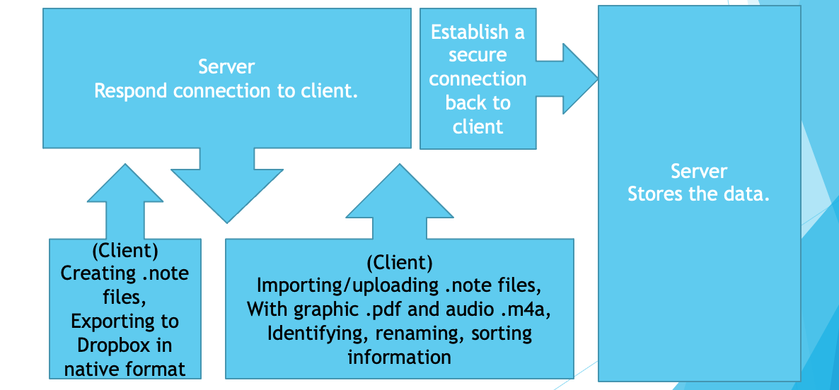In Notability the backup module is very simple and it happens without user’s consent once it’s being correctly set up. To set up is very simple and all the user need to do is enter the notability setting and backup function and login with their iCloud storage account like google drive.

(Slabin, 2015)

First, the client (user) create a note, the data is being stored as .note format which contains all the information whether is graphics, pdf, audio. These data are first stored locally on that machine. machine and can be accessed locally. However, for the client to be able to manage information across multiple devices the Client will need to use the backup function to back up and “Cloud storing” the date on network machine whether is local land or over the internet. To connect the storage machine, it uses TCP connection. Client send a request to the server to saying “hi I want to connected with you so I can store information on you” but to do so they need to establish a connection so they send a SYN to the server. Once the server received a request it respond it back to the client with a SYN ACK and at last the client respond it back to the server with ACK saying “Hi we are successfully connected”. This is a typical 3 way “handshake”. However, If the server requires a user name and password there will be further handshakes to be made to establish a much more secure tunnel.

After establish connection with the server data can be transferred between the client and the server. (Access control user privilege) To access and edit the data on the server, client can download the file and edit it on local machine. This means files that are on the sever does not get edited directly by client. After the client complete the changes to the data/file, file gets upload back to the server and the file that’s been downloaded and edited will get replaced.

The benefit of this data flow is that it can save storages on the local client and because the data is store on cloud it can be access by multiple clients at the same time as long as they have connection to the server.

**Networks**

Network in computer science is two or more devices that are connected together, usually by cables or Wi-Fi. Networking with others allows you to communicate and exchange information for a greater distance and they are 2 types of network: a local area network (LAN) and a wide area network (WAN). A LAN connection are usually used when devices that are connected together over a small area like within a home to share files, data and hardware like printer and internet connections together. A WAN works the same way like LAN connected with cables or Wi-Fi but in a greater scale in numbers of devices, longer distance and they work the same way and serves the same purpose that allows you to share files, data and hardware like printer across much greater distance around the globe. The internet that we use daily is actually a WAN connection that connects to billions of devises and hardware. (What is a network? - Introduction to networks - KS3 Computer Science Revision - BBC Bitesize, n.d.) There are two main types of connection: TCP and UDP. A TCP is a connection-oriented protocol, it’s secure as it requires a response from the connected computer but it is slow. A UDP is a connection-less protocol fast but less secure as it does not require a response.

Network in Notability:

Although, just to use notability doesn’t necessary require network connections but to use the backup function it does require connections to the internet. Here is a diagram show how Notability connect Google Drive to backup through internet:

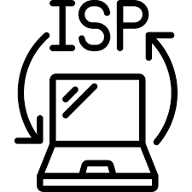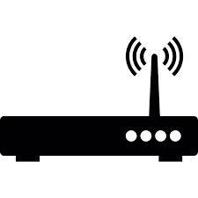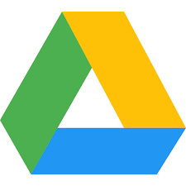

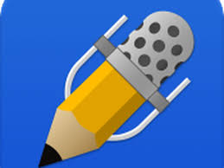

(Notability) (router) (internet service provider) (internet) (Google Drive)

For Notability to backup data to Google Drive it needs to go through a series of connections before reaching the Google Drive server. First the device that Notability is installed on need to know the public IP address of the Google Drive server so it uses DNS server (Domain Name System server). DNS server is like a phonebook of internet that tells you the address (public IP) of “people” and your device need this information to connect to the correct “address”. DNS is mostly default to use UDP Port 53 and only uses TCP when it is unable to communicate on UDP. (Is DNS TCP or UDP Port 53? | Infoblox DNS Security Center FAQ, 2018) However, before go through router, ISP and internet to a DNS server to find the address, it checks its local “phonebook”, DNS cache. A DNS cache is a stored “phonebook” that keeps the information of the server they wish to connect to. It is faster to resolve a domain to an IP address that it has visited before. The down side of is that it is vulnerable for DNS cache poisoning, also known as DNS spoofing that changes your DNS cache and divert your internet traffic away from the legitimate serves and towards fake ones. Anyway, if the request cannot be resolved from the cache it will has to communicate with a DNS server on the internet first then uses that information to connect from internet to Google Drive. A complete flow is that Notability connect to router to ISP and connect through the internet through a series of computer if the server is too far away then reaches the Google drive server.

**Reference:**

Notability. 2019. Importing, Exporting, And Sharing Notes (Mac). [online] Available at: <https://support.gingerlabs.com/hc/en-us/articles/206031287-Importing-Exporting-and-Sharing-Notes-Mac-> [Accessed 22 November 2020].

Le, J., 2018. How Operating Systems Work: 10 Concepts You Should Know As A Developer. [online] Medium. Available at: <https://medium.com/cracking-the-data-science-interview/how-operating-systems-work-10-concepts-you-should-know-as-a-developer-8d63bb38331f> [Accessed 22 November 2020].

Le, J., 2018. Computer States Graph. [image] Available at: <https://miro.medium.com/max/1200/1*KTbvb5KA501gYqsfv39k6Q.jpeg> [Accessed 22 November 2020].

Home.adelphi.edu. n.d. CSC 170-Introduction To Computers And Their Applications. [online] Available at: <https://home.adelphi.edu/~siegfried/cs170/170l1.pdf> [Accessed 22 November 2020].

Support.gingerlabs.com. 2020. Taking Notes – Notability. [online] Available at: <https://support.gingerlabs.com/hc/en-us/sections/200838557-Taking-Notes> [Accessed 29 November 2020].

Slabin, U., 2015. Notability Data Management. [online] Slideshare.net. Available at: <https://www.slideshare.net/uladzimir/notability-data-management-paddatamgmt> [Accessed 29 November 2020].

BBC Bitesize. n.d. What Is A Network? - Introduction To Networks - KS3 Computer Science Revision - BBC Bitesize. [online] Available at: <https://www.bbc.co.uk/bitesize/guides/zc6rcdm/revision> [Accessed 29 November 2020].

Infoblox. 2018. *Is DNS TCP Or UDP Port 53? | Infoblox DNS Security Center FAQ*. [online] Available at: <https://www.infoblox.com/dns-security-resource-center/dns-security-faq/is-dns-tcp-or-udp-port-53/> [Accessed 29 November 2020].